St. Mary the Virgin, Calverleigh
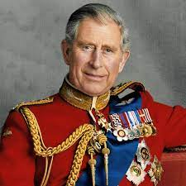

King Charles III
Coronation Celebration service

Sunday 7th May 2023
at
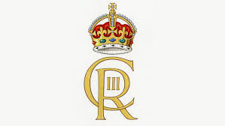
10.45am

Followed by
Bring and Share lunch
in church
With celebration cake
And a toast to the King

You are welcome to join us

